
Peaks Fall Newsletter 2024

Greetings / Announcements
A fall hello to all. 🍁
We wanted to let everyone know that the impact of Hurricane Helene is still quite devastating in areas of Ashe County and throughout the high country of western NC,The Peaks neighborhood was spared from any major damage from the storm. We did have flooding, broken, uprooted fallen trees and downed power lines, and multiple days without electricity. It was a relief to have everyone reported as safe that first day following the storm.The Laurel Springs Volunteer Fire Department did a wellness check and offered assistance right after the storm. The roads did maintain their integrity and only washed in a few spots.The roads were cleared of downed trees by residents inside The Peaks which gave us safe ingress and egress. Thank you to all that provided assistance. We have much to be grateful for.

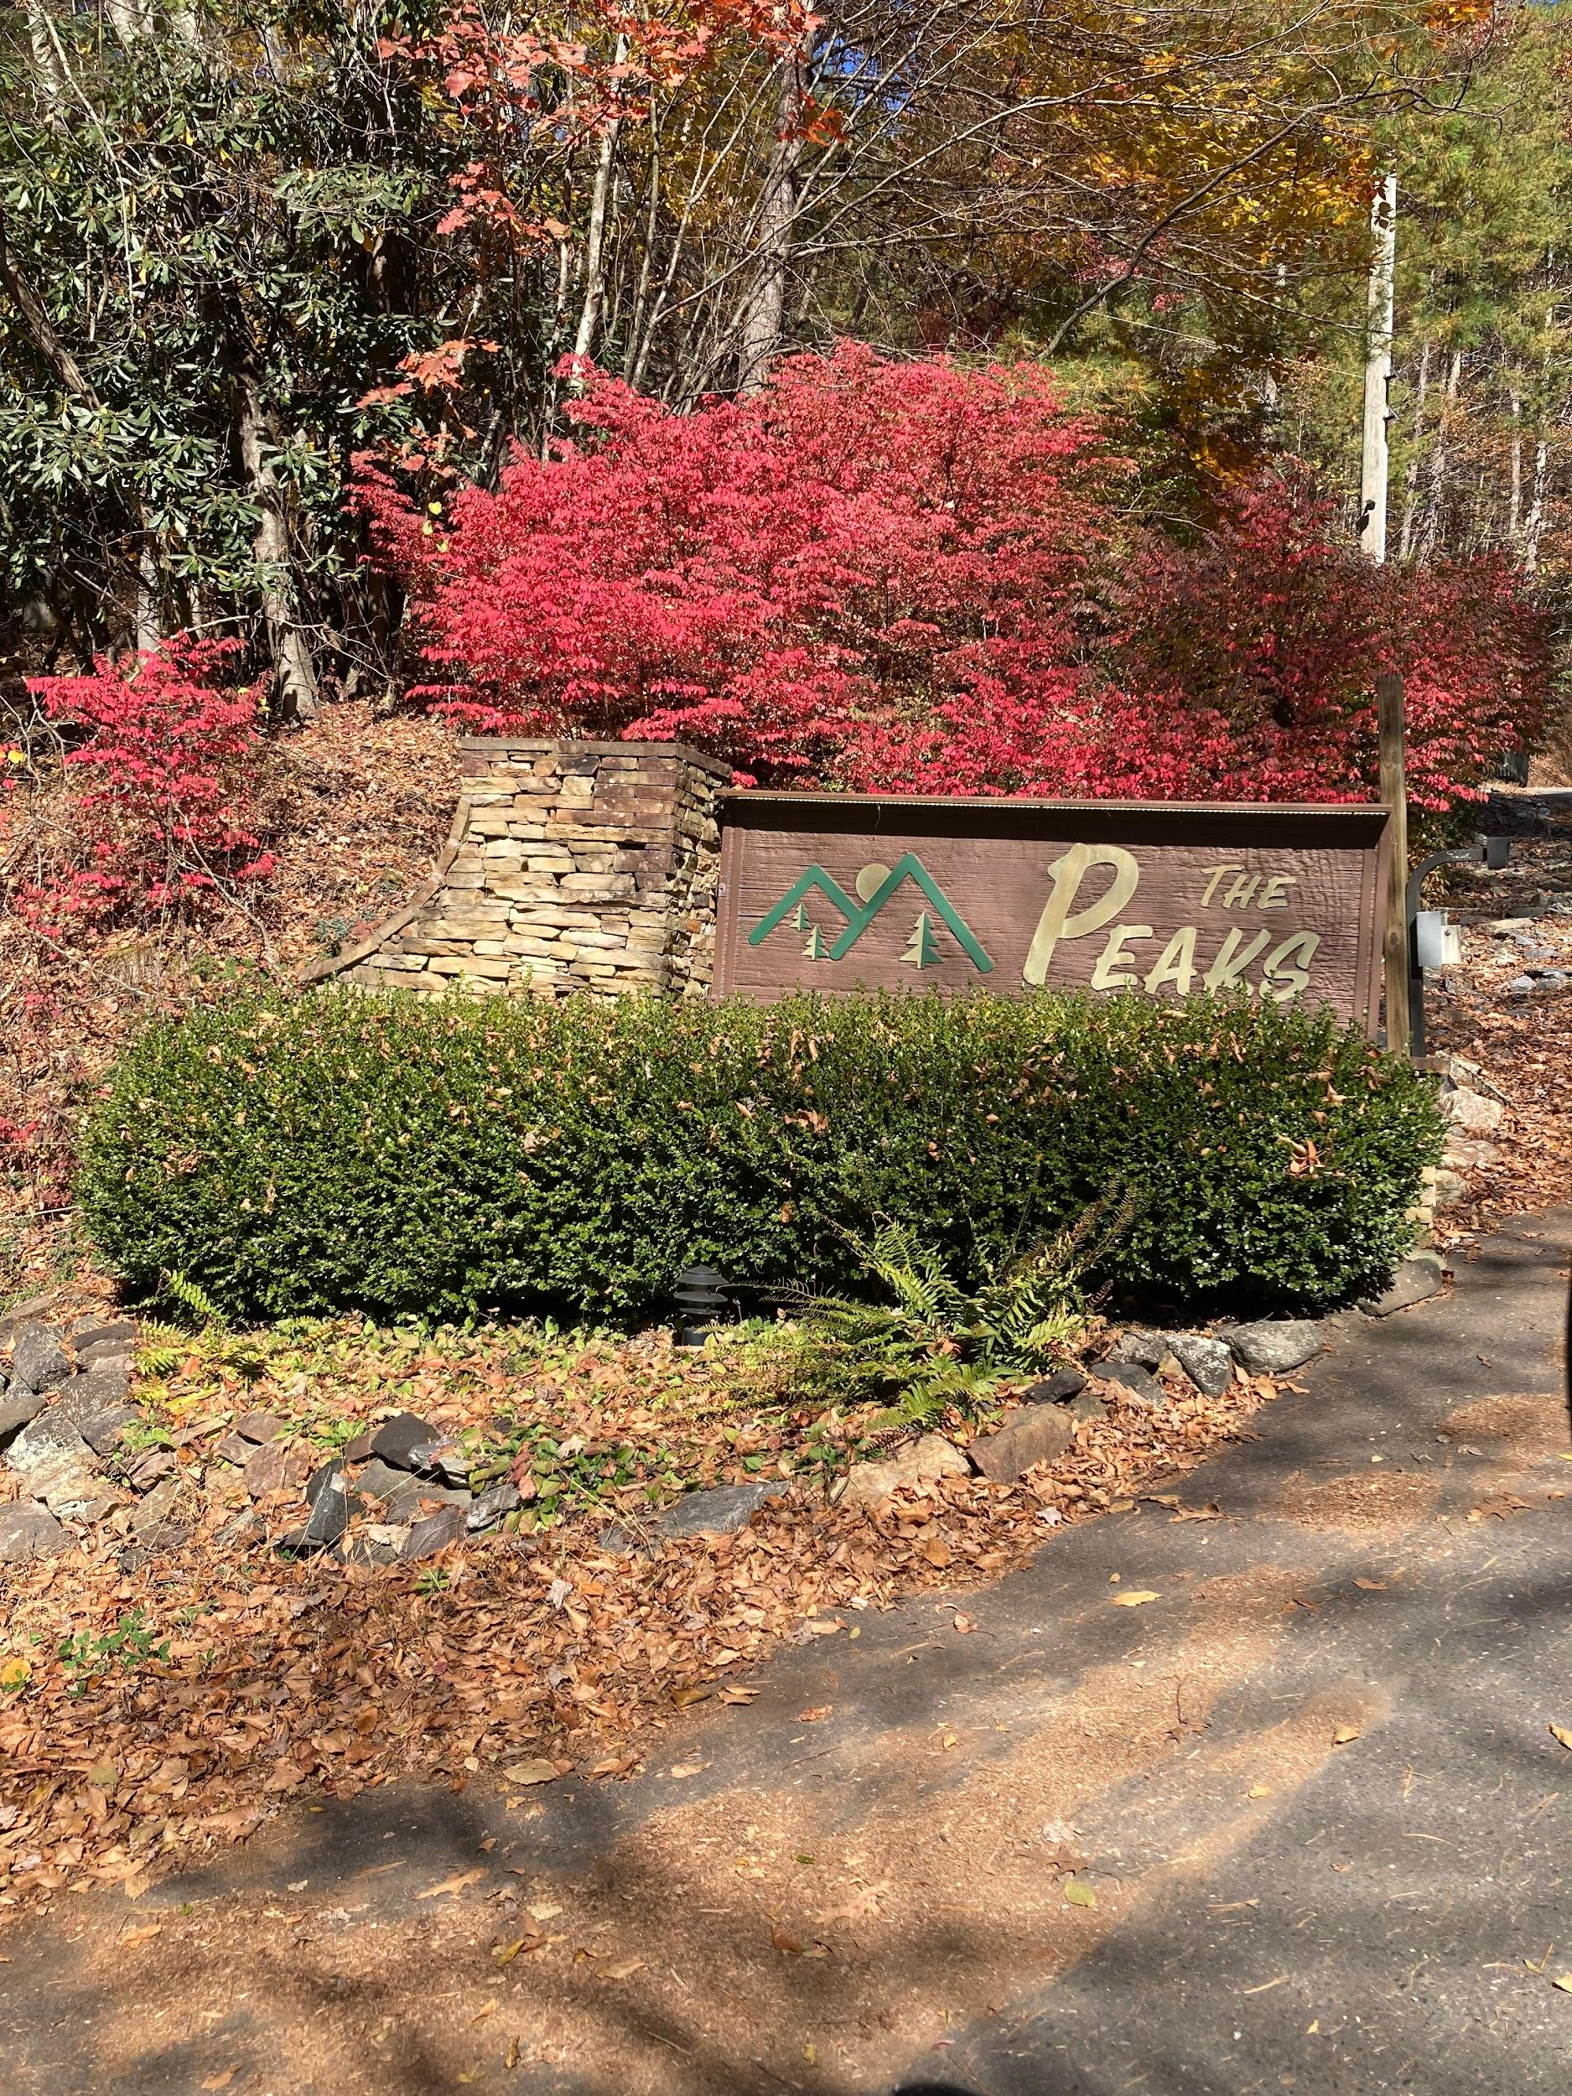l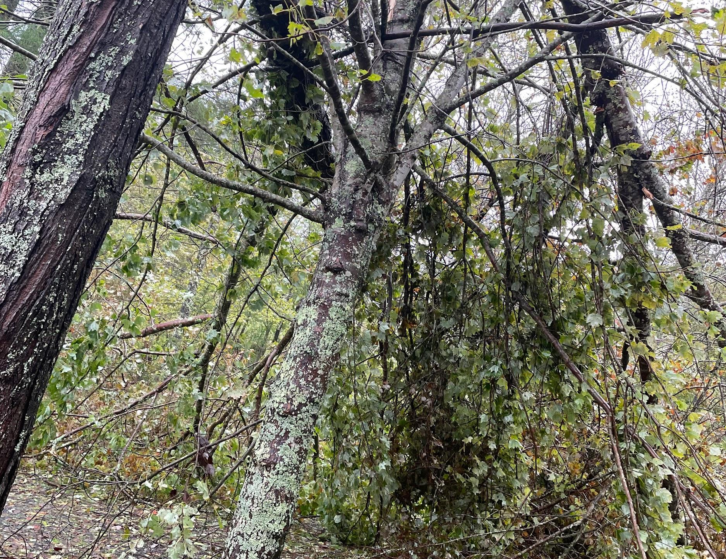
The recovery and rebuild of the region will take some time. If you are interested in volunteering please find sources at the following link. Ashe county strong
Stay Connected
If have your updated contact information, You may send to our email address:peakspoa@gmail.com or submit to our website at thepeakspoa.org

Neighborhood Reminders The neighborhood speed limit is 15 mph. This is a safety and dust control speed.All drivers should be age 16 and licensed.
All Lot owners should submit their plans for any structure to the Peaks Architectural Committee and should have their own well and septic permitted and installed.
No Camping, RVs or Motor Homes are allowed in the Peaks.
There are no firearms or fireworks permitted inside the Peaks.
Security Cameras are provided at our entrance and exits for your safety.
The current gate code is 2032. A new front gate is installed after the Annual meeting next summer. The gate will be locked in an open position should we have inclement weather threats through the winter.
Wishing everyone a healthy and safe holiday season.
Plans for 2025
We hope you will plan to attend the Peaks POA Annual Meeting. It will be Saturday 6/27 or Sunday 6/28. Once final arrangements are made we will get more details distributed.
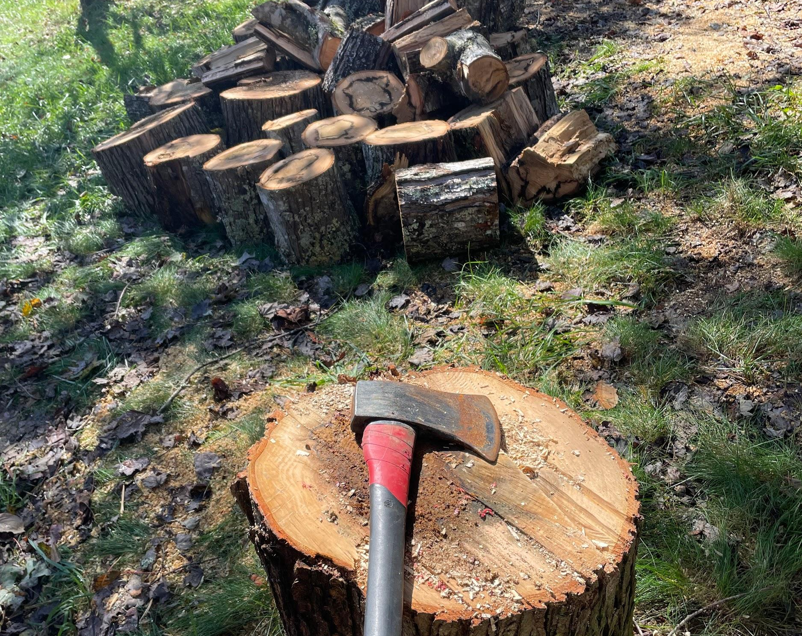
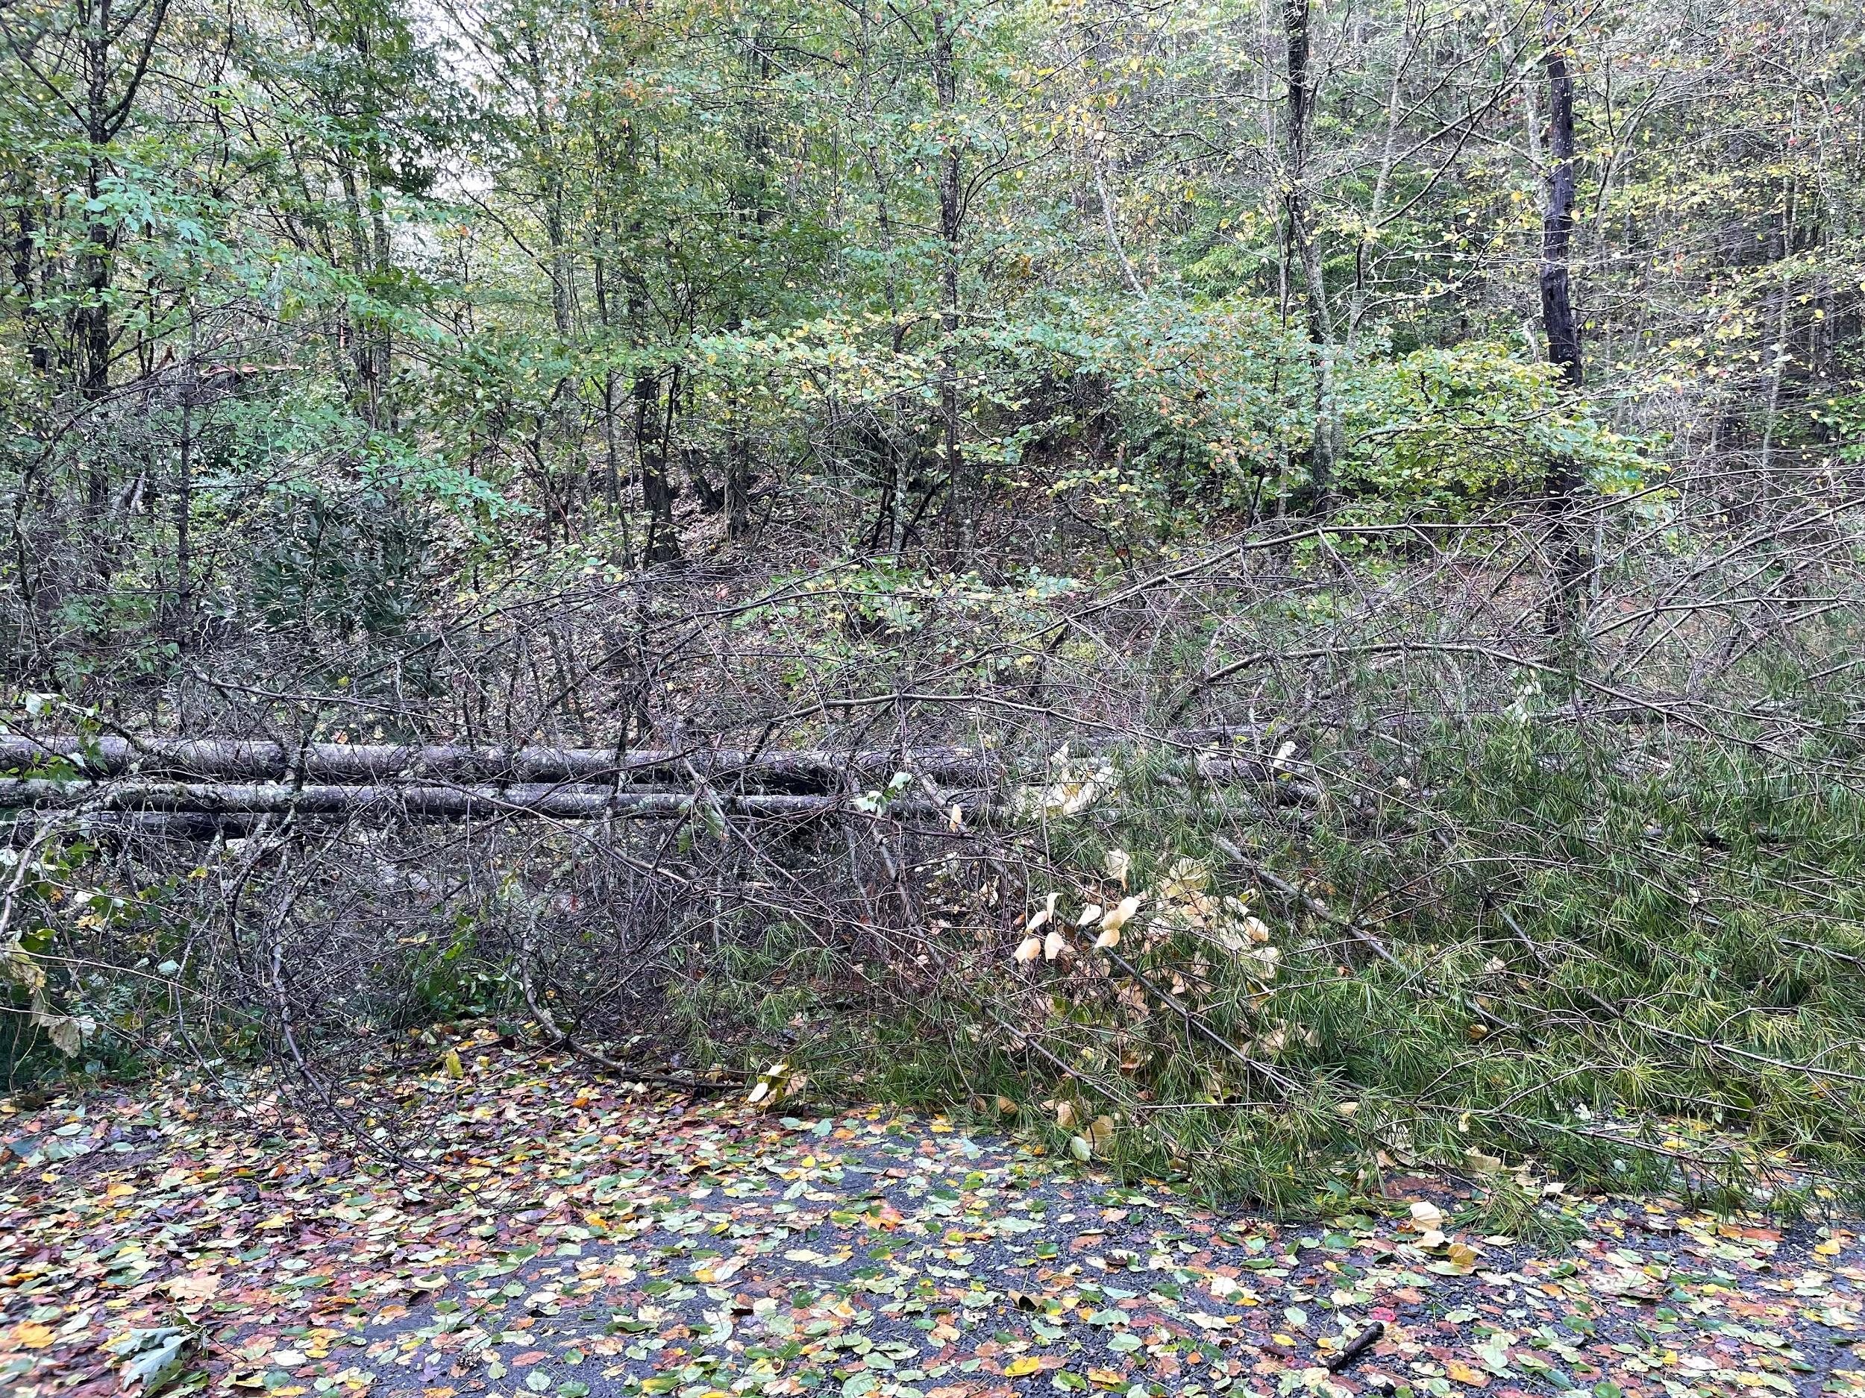

Peaks Property Owners Association
P.O. Box 110
Jefferson, NC 28640

peakspoa@gmail.com
thepeakspoa.org

